Supplemental Primary Source Documents

Document C

A Negro Man Named Jack, Born in Martinique
(Transcription modified for length and clarity.)
This “runaway” advertisement was printed in the September 25, 1770 issue of “The Essex Gazette,” a Salem newspaper owned by colonist, Samuel Hall. Advertisements for “runaway” enslaved people and people “for sale” were common and an important source of revenue for newspaper printers.
The advertisement describes an enslaved man named Jack, born on the island Martinique, a French colony in the West Indies.
Runaway from the Subscriber, on the 17th, at night, a Negro Man, named Jack, about 6 feet high, near 50 years of age, speaks bad English, and born in Martinico (Martinique). Had on when he went away, a blue coat with mohair buttons, a black jacket with black glass buttons, blue breeches with white metal buttons, and a red cap, but may have changed his clothes, as he had more at Beverly.
Whoever shall take up said Negro, and deliver him to Mr. Brown, Deputy-Sheriff, in Salem, shall have two dollars reward, and all necessary charges paid to them.
All masters of vessels, and others, are cautioned against carrying said Negro off, to avoid the penalty of the law.
Joseph Homan
Marblehead, Sept. 22, 1770.

Vocabulary
- Subscriber: the person who wrote this advertisement (and likely regularly receives this newspaper)
- Breeches: type of pants
- Masters: ship captains
- Vessels: ships or boats

Document C
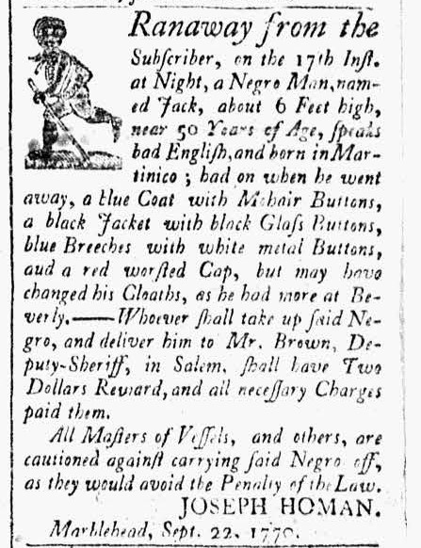

Image Source
“The Essex Gazette”, September 25, 1770. Vol. II, No. 113. Courtesy of Readex: America’s Historical Newspapers. Early American Newspapers, Series 1: From Colonies to Nation.

Document C
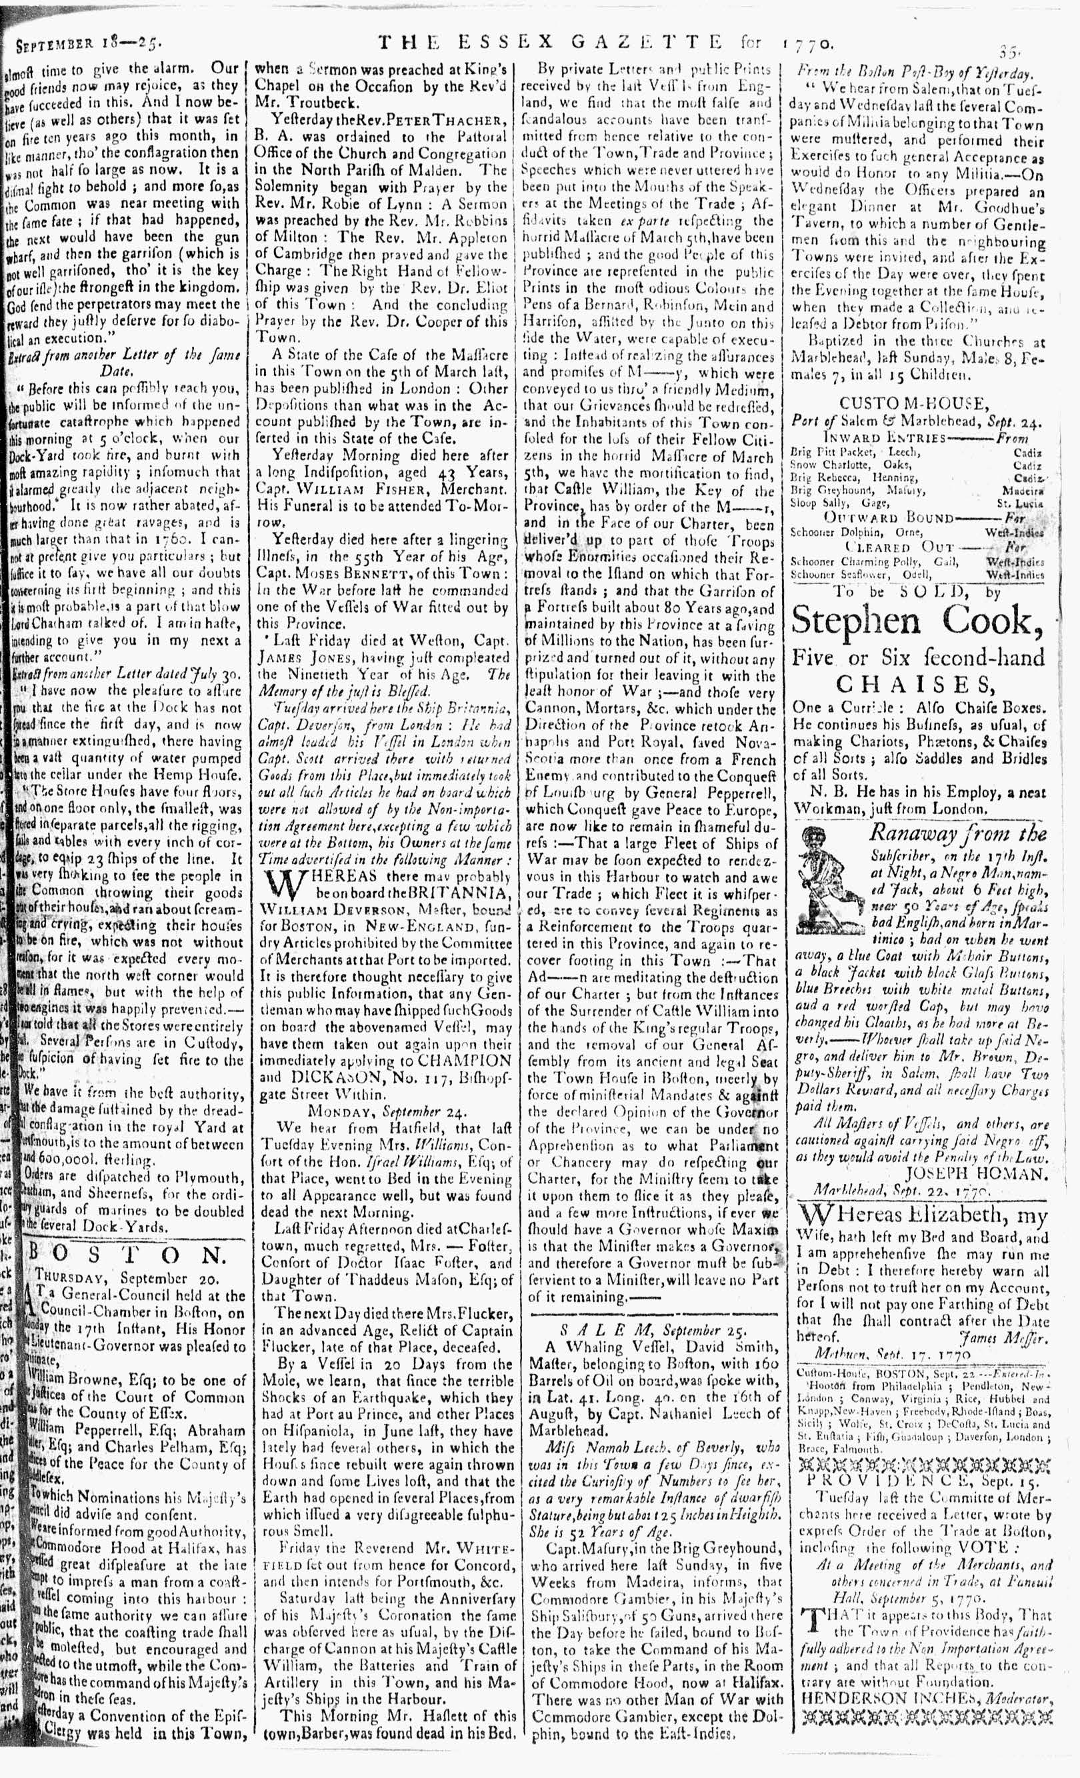

Image Source
“The Essex Gazette”, September 25, 1770. Vol. II, No. 113. Courtesy of Readex: America’s Historical Newspapers. Early American Newspapers, Series 1: From Colonies to Nation.

Document D

Choice Jamaica Sugar & Rum
(Transcription is modified for length and clarity.)
Richard Derby Jr. was the son of Salem merchant and ship captain Richard Derby. Like his father, he was a merchant who bought, sold, and traded goods produced on slave plantations in the West Indies. He placed this advertisement in the Salem newspaper, “The Essex Gazette” on October 17, 1769. Underneath appeared a “for sale” advertisement for a teenage boy. He appears to have been trained in woodwork (making barrels) and experienced in field and garden labor.

Just imported, and to be sold, by
Richard Derby, junior
Choice Jamaica sugar, rum, allspice, ginger, and coffee.

To be sold,
A likely Negro lad, about eighteen or nineteen years of age, works well at the cooper’s trade and understands working in the field or garden. ---Enquire of the Printer.

Vocabulary
- Cooper’s trade: making wooden casks or barrels
- Enquire: to ask

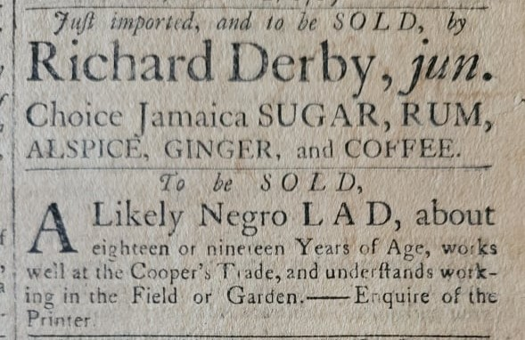

Document D
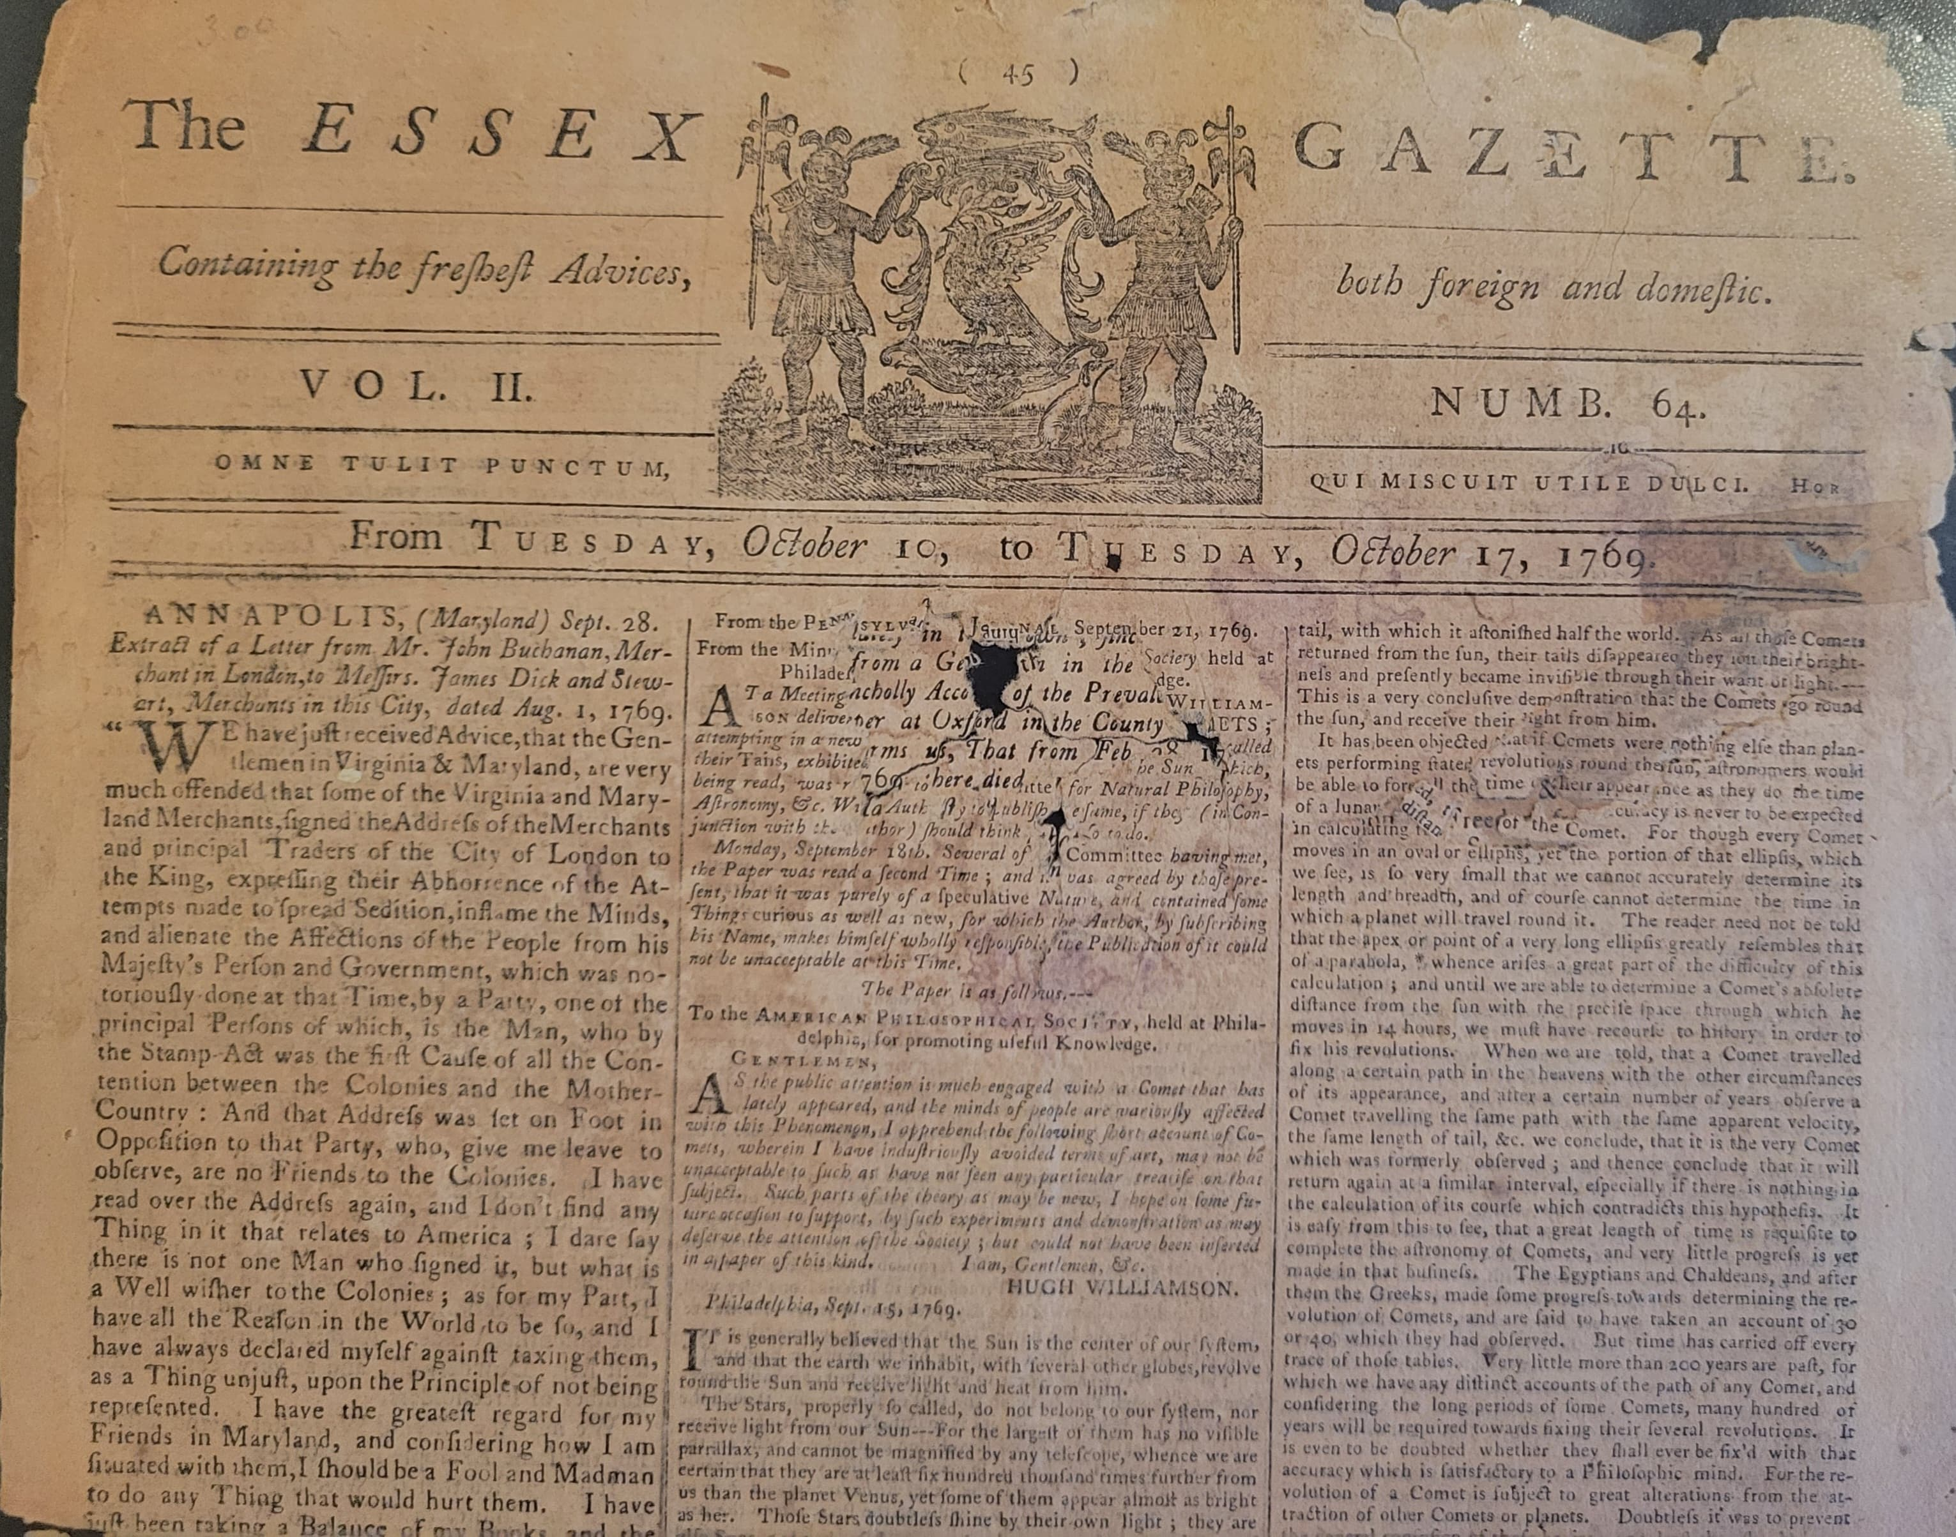

Image Source
“The Essex Gazette”, October 17, 1769. Vol. II, No. 64. Museum of Printing, Haverhill, MA. NPS Photo.

Document E

Map of the West Indies
This 1715 map of the West Indies identifies French, Dutch, Spanish, and English colonies.

Image Source
Moll, Herman, 1732, and Thomas Bowles. A map of the West-Indies or the islands of America in the North Sea; with ye adjacent countries; explaining sic what belongs to Spain, England, France, Holland, &c. also ye trade winds, and ye several tracts made by ye galeons and flota from place to place. [London Printed for Tho. Bowles, 1715] Map. https://www.loc.gov/item/gm71005442/

Document E
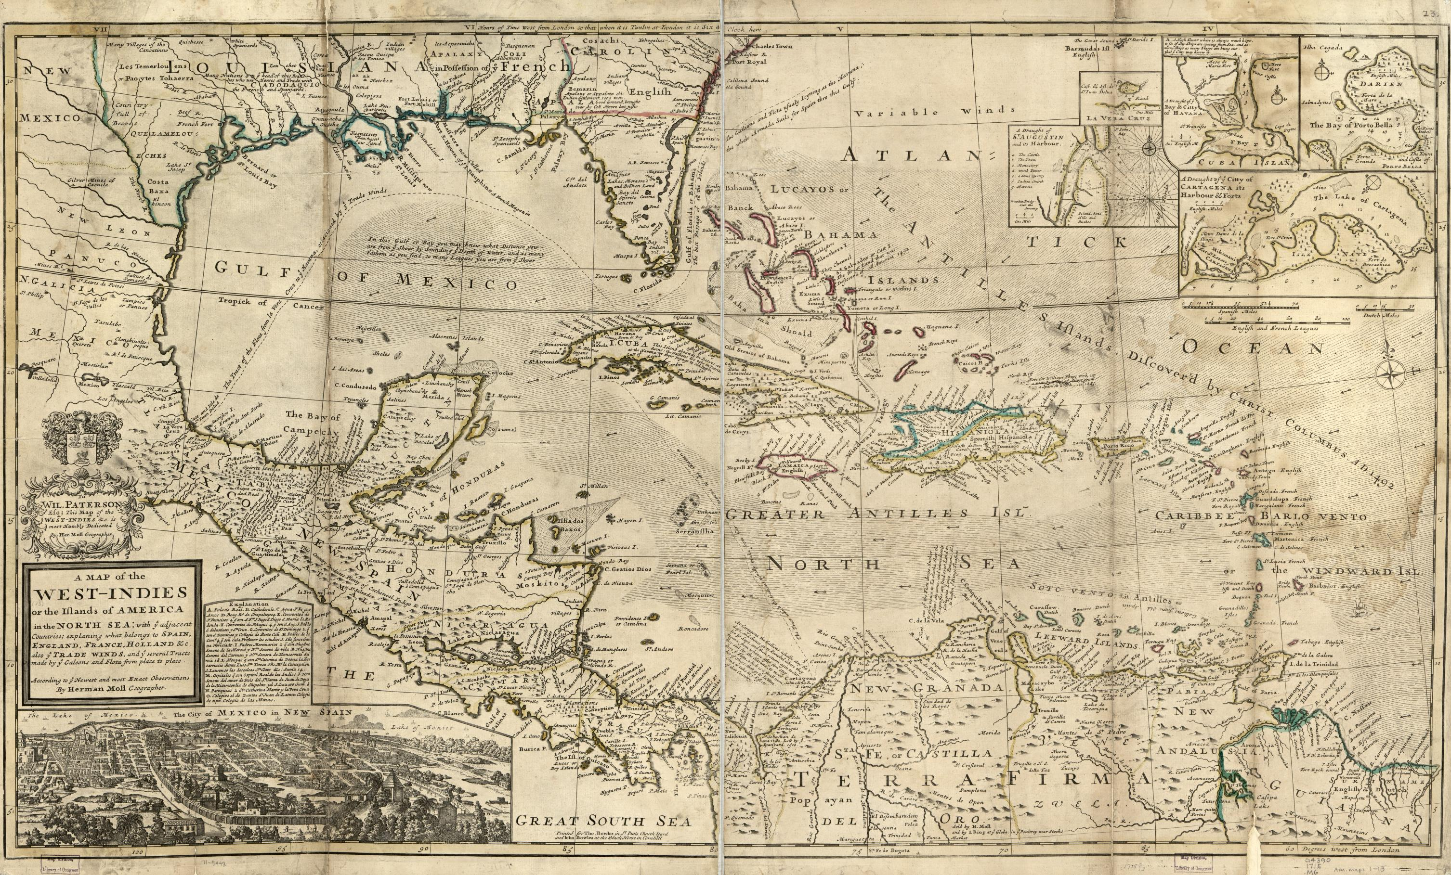

Document F

Cutting Sugarcane
This image is from the 1823 book, “Ten Views in the island of Antigua : in which are represented the process of sugar making, and the employment of the Negroes, in the field, boiling-house and distillery.” This image shows enslaved people (adults, children, and elderly people) cutting and binding sugarcane. Sugarcane, about 9 feet tall, was harvested with sharp, curved knives. Even young children work to bind sugarcane during harvest time. The hierarchy of the plantation is illustrated by the white man looking down from his horse to speak with a Black man, possibly an enslaved overseer, who has removed his hat.
Important note: the purpose of the “Ten Views in the island of Antigua” book and its images was to gain support for slave plantations in the West Indies. Enslaved people were likely not clothed as well as the appear in this image.

Image Source
Clark, W. A. V. (William A. V.), Ten views in the island of Antigua : in which are represented the process of sugar making, and the employment of the Negroes, in the field, boiling-house and distillery/ Ten Views in the Island of Antigua, [London], Thomas Clay, 1823, hand-colored aquatint, Yale Center for British Art, Paul Mellon Collection, [London] : Published by Thomas Clay, Ludgate-Hill, London, 1823.

Document F
